**Read Me !!**

Please Follow the instructions below before executing the project:

* **What Does Your PC Needs !!**

To run the website, you need to install the specified plugins/imports:

1. **Django:**

**Installation Process:**

1. Open Command Prompt.
2. Enter Command “pip install Django”
3. **pytrends:**

**Installation Process:**

1. Open Command Prompt.
2. Enter Command “pip install pytrends”
3. **Jsons:**

**Installation Process:**

1. Open Command Prompt.
2. Enter Command “pip install jsons”
3. **pandas:**

**Installation Process:**

1. Open Command Prompt.
2. Enter Command “pip install pandas”

* **Process to run website in local browser:**

**Step1:**

* Extract Downloaded ZIP file. Copy the “**Python_Project_Final”** file present inside the ZIP to your desktop to your desktop.
* Open Command Prompt

**Step2:**

* + Change directory.

**Command:**

Cd Desktop\Python_Project_Final\mysite

**Step3:**

* + Run Server:

**Command:**

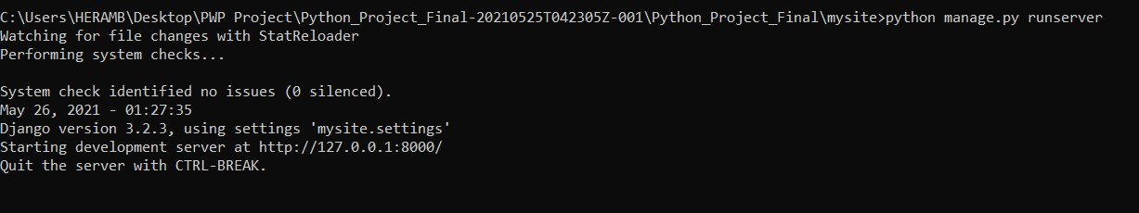 python manage.py runserver

**Step4:**

Find the above link and paste it in your browser.

**Note:** The link will not be similar as specified above because it is hosted locally on your pc.

* 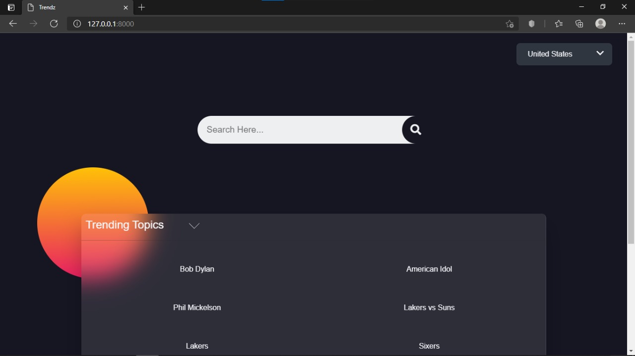The Website will be displayed as Follows: